Virtual Immunohistochemical Image Generation from Hematoxylin and Eosin Stained Slides Using Deep Learning

Abstract:
Breast cancer diagnosis often involves immunohistochemical (IHC) staining to identify specific protein expressions like HER2, which plays a crucial role in determining the treatment strategy. However, IHC staining is time-consuming, costly, and destructive to tissue samples. This project aims to address these challenges by generating synthetic IHC images directly from hematoxylin and eosin (H&E) stained slides using deep learning techniques.
By leveraging generative models, particularly image-to-image translation frameworks, the system virtually simulates IHC-stained images with high fidelity. This non-invasive method preserves tissue integrity, reduces laboratory costs, and allows clinicians to evaluate multiple markers from a single H&E sample. The web-based interface, developed using Python and Flask, enables easy upload and retrieval of images. The solution, integrated with XAMPP for backend data handling, supports effective visualization and storage.
Existing System:
The current clinical workflow for assessing protein expression in breast cancer includes:
- Manual tissue sectioning
- Application of IHC staining protocols
- Microscopy-based evaluation of stained slides

Disadvantages of the Existing System:
- High cost due to reagent and processing requirements
- Sample destruction due to multiple staining processes
- Limited tissue availability for multiple marker analysis
- Dependency on human interpretation, introducing subjectivity
- Time-intensive laboratory procedures

Proposed System:
The proposed system utilizes a deep learning-based image-to-image translation model (e.g., Pix2Pix) to generate synthetic IHC images from H&E stained tissue slides. The web application allows users to upload H&E images and receive the corresponding virtual IHC-stained image. All image processing and model inference are handled through a Flask-based backend, with data managed using XAMPP and MySQL.

Advantages of Proposed System:
- Non-destructive approach to tissue analysis
- Eliminates cost and time of traditional IHC processing
- Enables multi-marker visualization from a single H&E slide
- Promotes early and more accurate treatment decisions
- Facilitates remote access and digitization via web interface

Modules Used in the Project:
- User Interface Module:
  - Upload and view images
  - Download generated IHC images
- Preprocessing Module:
  - Resize and normalize H&E images
  - Prepare input for model
- Model Inference Module:
  - Load and apply the trained deep learning model
  - Generate synthetic IHC image
- Post-Processing & Output Module:
  - Enhance and format generated image
  - Save and render for UI
- Database Module (XAMPP MySQL):
  - Store uploaded and generated image paths
  - Maintain user session and activity logs

Algorithms / Models Used:
- Pix2Pix (Conditional GAN):
  - Used for paired image-to-image translation.
  - Learns mapping from H&E image domain to IHC domain.
  - Consists of generator and discriminator networks.
- U-Net (for segmentation-based variant - optional):
  - If HER2 expression localization is desired.

Software Requirements:
- Operating System: Windows 10/11 or Linux
- IDE: Visual Studio Code / PyCharm
- Backend: Python 3.x, Flask
- Deep Learning: TensorFlow / Keras / PyTorch
- Frontend: HTML5, CSS3, Bootstrap
- Database: MySQL via XAMPP
- Libraries: OpenCV, NumPy, Pillow

Hardware Requirements:
- Processor: Intel i5 or higher
- RAM: 8 GB minimum
- GPU: NVIDIA GPU with 4GB+ VRAM (optional but recommended for training)
- Storage: Minimum 10 GB free space

Problem Statement:
Traditional IHC staining methods for protein expression analysis in breast cancer are expensive, labor-intensive, and require multiple samples for different biomarkers. There is a need for a cost-effective, non-destructive approach to derive IHC-equivalent information from commonly available H&E stained tissue images.

Scope of the Project:
- Enable automatic generation of virtual IHC slides from existing H&E slides
- Reduce clinical turnaround time and staining costs
- Serve as an AI-assisted diagnostic tool for pathology labs and hospitals
- Facilitate research into multi-marker analysis without depleting samples

Limitations of the Study:
- Accuracy depends on the quality and quantity of training data
- Not yet a replacement for real IHC in legal or regulatory diagnosis
- Requires GPU acceleration for real-time inference
- Cannot yet generalize across all cancer types and staining protocols

References:
- Isola, P., Zhu, J.Y., Zhou, T., & Efros, A.A. (2017). Image-to-image translation with conditional adversarial networks. CVPR.
- Ronneberger, O., Fischer, P., & Brox, T. (2015). U-Net: Convolutional Networks for Biomedical Image Segmentation. MICCAI.
- The Cancer Genome Atlas (TCGA) - Histopathology Datasets
- Papers with Code: https://paperswithcode.com/task/ihc-image-generation

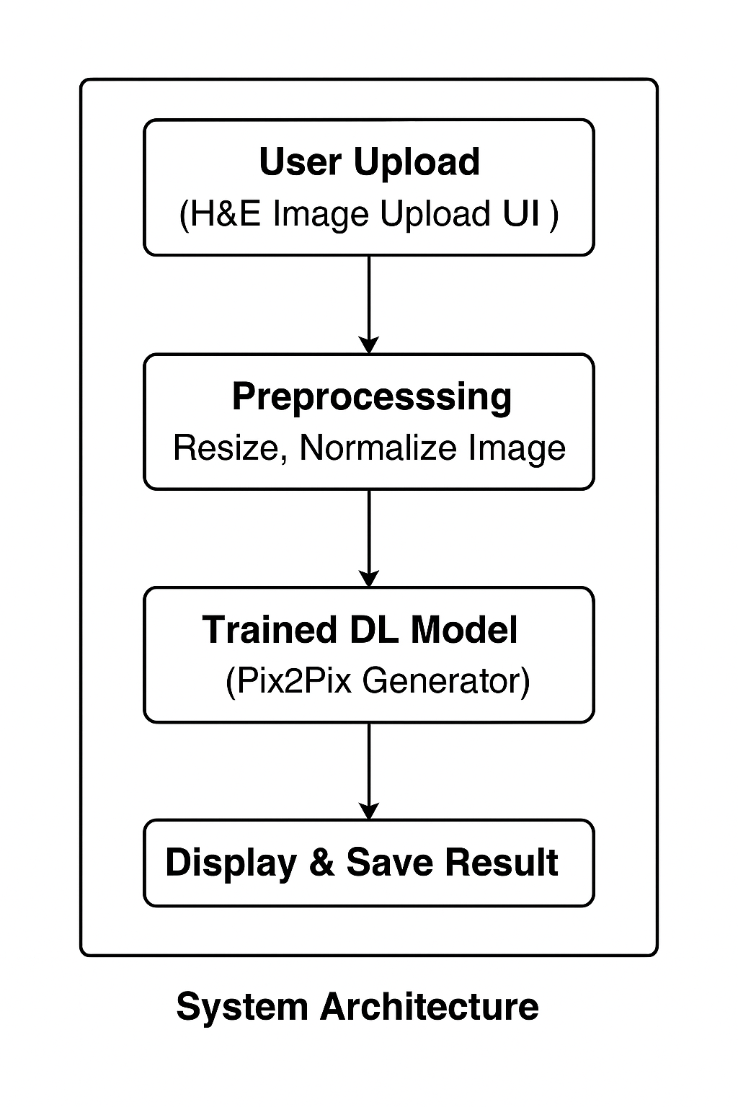
Literature Survey
1. Traditional IHC Methods and Limitations
Immunohistochemistry (IHC) is a widely used laboratory method in pathology for detecting specific antigens in tissue sections through antigen-antibody binding. Although IHC is the gold standard for determining the presence of biomarkers like HER2, it comes with notable limitations, such as high costs, labor-intensive procedures, and tissue destruction during staining. Additionally, each target protein requires a separate staining process, which further depletes limited biopsy samples and increases turnaround time. Researchers have recognized the inefficiency and cost burden of traditional IHC in large-scale clinical settings, especially in low-resource environments.
2. Role of H&E Staining in Diagnostics
Hematoxylin and eosin (H&E) staining is the most commonly used method in pathology to observe general tissue morphology. H&E slides are less expensive and non-specific, but they offer high-resolution images that reveal structural details. These slides are digitally scanned and archived in many hospital systems, creating a vast resource of labeled morphological data. However, while H&E provides morphological insights, it lacks molecular specificity. Researchers began investigating whether molecular expression patterns could be inferred computationally from morphological data present in H&E images.
3. Emergence of Deep Learning in Histopathology
The advent of convolutional neural networks (CNNs) and generative adversarial networks (GANs) has transformed digital pathology. Early applications of CNNs focused on image classification tasks—such as detecting cancerous vs. non-cancerous tissue. GANs extended these capabilities by enabling high-quality image synthesis. Researchers such as Isola et al. (2017) introduced Pix2Pix, a conditional GAN for image-to-image translation that has been applied in medical domains including MRI-to-CT conversion, synthetic organ imaging, and histopathology.
4. H&E to IHC Translation
Recent studies have explored the concept of predicting or generating synthetic IHC images directly from H&E-stained tissue. A pioneering effort by Xu et al. demonstrated that GAN models trained on paired H&E-IHC image datasets could approximate the distribution of protein expressions typically revealed through IHC staining. This method enables non-invasive, cost-effective, and rapid generation of virtual IHC slides that approximate the biological patterns seen in true IHC slides.
Furthermore, studies have reported high correlation between synthetic and real IHC slides for specific markers like HER2 and Ki67. These efforts open up the possibility of reusing archival H&E slides for virtual biomarker analysis, effectively doubling their diagnostic utility.
5. Image-to-Image Translation with Pix2Pix
The Pix2Pix framework has emerged as a preferred architecture for paired image translation tasks, including histological domain conversions. The generator learns a mapping function from input (H&E) to output (IHC), while the discriminator ensures the realism of generated outputs. Researchers have optimized the loss functions by combining adversarial loss with L1 loss to improve pixel-level accuracy.
In various biomedical applications, Pix2Pix and its enhanced versions (e.g., CycleGAN for unpaired data) have been used to perform modality translation tasks where collecting ground truth data is expensive or infeasible.
6. Web Integration in Diagnostic Tools
To make AI tools accessible to healthcare professionals, many researchers have incorporated deep learning models into web-based platforms using Flask or Django. This approach ensures real-time access, remote deployment, and usability across hospitals. Integration with XAMPP and MySQL has been a preferred stack for academic and prototype-stage deployments, allowing researchers to focus on the inference pipeline without building complex infrastructure.

